**Steel: Pittsburgh**

One possible set of intertwined ecological and medial dynamics derived from the "Steel: Pittsburgh" board game could be the exploration of the environmental impact of industrialization and the role of media in shaping public perception and policy responses. This project could take the form of a multimedia exhibition, combining geography, history, and some interactive elements. The exhibition could reveal real-life images of Pittsburgh's industrial landscape intertwined with historical footage and interviews highlighting the city's environmental history. The exhibition could also incorporate sections exploring how media representations, such as news coverage and advocacy campaigns, have influenced public awareness and government regulations regarding environmental issues in Pittsburgh and beyond. By linking these disparate elements, the project aims to reveal the complex interdependencies between industrialization, media narratives, public perception, and environmental policy-making.

Welcome to *Steel: Pittsburgh*! In this game, you can choose to play as a member of the capitalists, environmentalists, or politicians, competing for resources, deploying strategies, and interacting with other players to achieve victory. In Pittsburgh, a city where industry coexists with nature, every decision you make will impact the city's future.

**Game Objective**

Your goal is to earn the most victory points through resource management and strategic decision-making. Capitalists aim to expand their industrial empires, environmentalists strive to preserve natural resources, and politicians seek to dominate the fate of the city.

**Game Components**

The Board: Displays the map of Pittsburgh and resource areas.

Character Cards (8): including Environmentalists (3), Capitalists (3), and Politicians (2).

**Environmentalists Roles:**

**The Environmentalist (Famous Pittsburgh Environmentalist)**

**Rachel Louise Carson**

One-time effect: Immediately remove all steel markers from the target plot, restore an ecosystem on the board that was destroyed by a development card, and prevent industrial expansion by capitalists.

**The Ecologist (World's Leading Environmental Scientist)**

**Alexander von Humboldt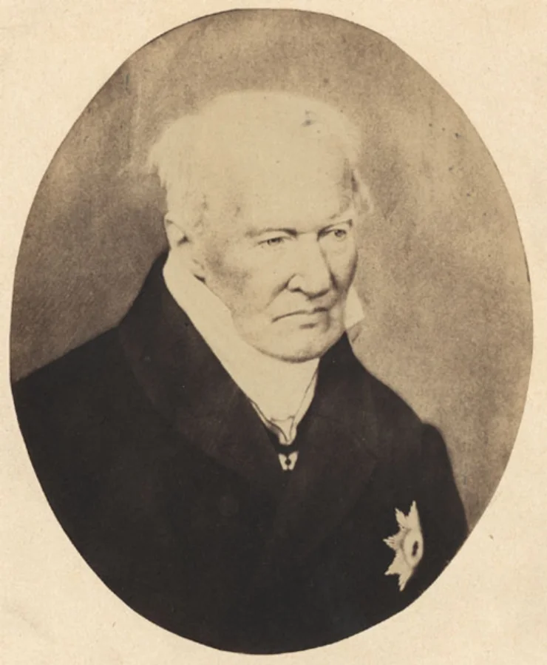**：

Possesses unique knowledge and skills that can accelerate the regeneration of resources and the restoration of natural environments.

Once per turn: Spend money to remove one steel marker from the target plot; if the chosen plot does not have a steel marker, instead place an environmental marker, indicating that the plot can never be developed industrially.

**The Green Activist**

**William S. Dietrich**：Capable of organizing demonstrations and protest activities within the city, limiting the actions of capitalists.

Once per turn, spend money/public opinion to launch a protest, making the development cards cost extra money/public opinion during this turn.

**Capitalist Roles：**

**Industrial Tycoon**

**Andrew Carnegie**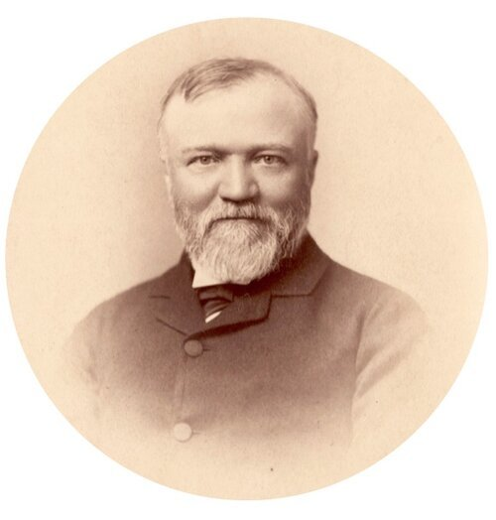 Possesses a wealth of resources and capital, capable of rapidly expanding their industrial empire in a short period of time.

Passive:

1. No limit to the number of times industrial development cards can be used.
2. For every two industrial development cards played, it is considered as an extra use of an industrial development card.

**Resource Developer**

**William Richard Jones**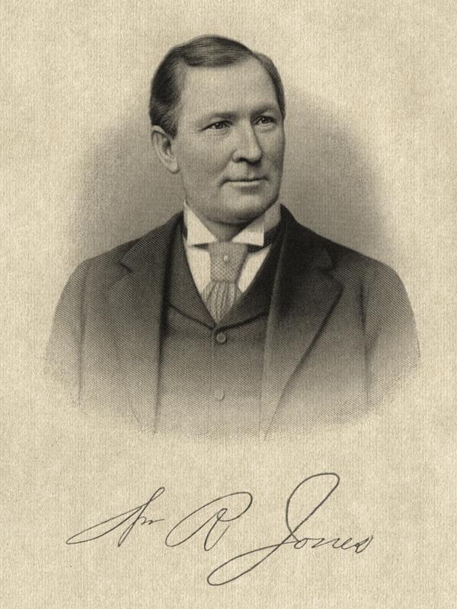 Skilled in extracting and developing resources, capable of acquiring a significant amount of resources in a short period of time.

Skill 1 - Mining: The steel and coal resources obtained from your plots are increased by one.

Skill 2 - Supply: Limited to once per playing phase, if you have a resource point total of two or more in your hand, you can play or give a teammate an industrial development card that does not require resources.

**Financier**

**Henry Clay Frick**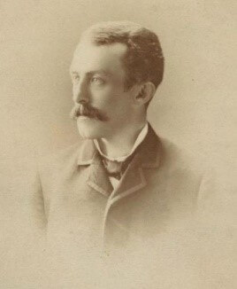 Proficient in financial investment and fund management, capable of effectively manipulating the market and gaining additional profits.

Skill 1 - Investment: At the start of the playing phase, you can invest all your money in a specific plot. When this plot is successfully developed by someone in your faction, you receive 120% of the invested amount back in money.

Skill 2 - Management: Limited to once per turn, at the start of the turn, immediately skip the next turn and receive money.

**Politician Roles：**

**Politician**

**James Blackmore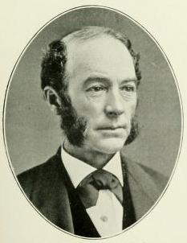**：Skilled in political maneuvering and negotiation, capable of influencing the passage of legislation and the outcomes of votes.

**Civic Representative**

**Andy Warhol**：Represents the interests of city residents, capable of mobilizing voters and social organizations to influence the direction of city politics.

**Special Items/Tokens**

Neutral (can be used by all three rolegroups):

**Resource Indicators**: Represent resources like steel, coal, wealth, and public opinion (votes).

**Territory Occupation Card**: Limited to once per turn, consume money + public opinion and faction tokens to place or remove a steel marker on a designated plot, used to mark resource development on the board.

**Goods Exchange:** Spend money to gain public opinion or spend public opinion to gain money. When money accumulates quickly to a certain amount, it can be used to bribe.

**You are Cancelled!**: Used to cancel another faction's councilor. The cancelled character is immediately overlaid, cannot take any action during the current turn, and skips the next round.

**Trade War:** Launch a strike on a specific plot, preventing the opposing faction from gaining money during this turn.

**Impeachment Card:** When public opinion quickly accumulates to a certain amount, it can be used to impeach another faction's councilor, preventing the councilor from gaining public opinion this turn.

**Capitalist Faction:**

**Construction Development Card**: Used to mark resource development on the board and destroy the ecological environment.

**Bribery Token**: When a significant amount of money is quickly accumulated, it can be used to bribe a character from another faction.

**Assassination Token:** Used to assassinate a politician from another faction.

Environmentalists Faction:

**Environmental Legislation Card**: Used to prevent an area from being developed or to restore the ecological environment of a developed area.

**Strike Token**: When public opinion quickly accumulates to a certain amount, it can be used to initiate a strike on a specific plot.

**Impeachment Token**: When public opinion quickly accumulates to a certain amount, it can be used to impeach a politician from another faction.

**7 Politician Factions:**

**Legislation Enforcement Card**: Used to enact seven types of laws, requiring votes from other factions.

**Pittsburgh Real Estate Law:** Reduces the cost of acquiring property to some extent.

**Pittsburgh Immigration Law:** Attracts a large number of immigrants looking for stable jobs.

**Pittsburgh Endangered Species Law**: Protects endangered animals in Pittsburgh, favored by scholars.

**Pittsburgh Water Source Law**: Time to provide clean water sources to residents! Gaining public opinion but demolishing industrial plots to construct new pipelines.

**Pittsburgh Royal Law:** Greatly reduces public opinion, clears all strike plots on the field, and grants $1000.

**Pittsburgh Reform Law:** Promotes university education and increases public environmental awareness.

**Pittsburgh Infrastructure Law:** Strongly promotes urban construction in close cooperation with the steel industry.

**American Democracy Token**: Used to forcibly change the status of a character from another faction (requires public opinion).

**Resource Score Card:** Used for scoring.

**Plot**

Both environmentalists and capitalists can achieve their respective game goals by placing markers on plots; each plot can hold up to three markers. For capitalists, they must first use a development card to mark a plot, then exchange money for resource markers (including steel, coal), and place any number of markers on a plot that has been developed; the number of resource markers represents the development level of the plot, and the higher the development level, the higher the monetary returns from the plot. For environmentalists, using an environmental act card can prevent a target plot from being developed. If effective, environmentalists can place the environmental act card on the plot for one turn, indicating that the plot cannot be developed temporarily.

**Setup Phase**

1. Place the board in the center of the game table so that all players can easily see it.
2. Place resource cards, construction development cards, environmental legislation cards, legislation enforcement cards, assassination tokens, impeachment tokens, American democracy tokens, strike tokens, bribery tokens, and resource score cards in their designated areas.
3. Each player randomly draws a character card from the pile to determine their identity, then groups into factions: Environmentalists, Capitalists, and Politicians.
4. Each faction selects player representative characters in the required numbers, ensuring each has appropriate representation.
5. The game starts with the player in the last digit position of the game start time; if it exceeds the total number of players, start with the player at the position of the remainder when divided by the total number of players. The first action player starts from the Homestead sector.

**Start of The Game**

The game is divided into multiple rounds, each including the following phases: Resource Acquisition, Action Phase, Event Phase, and Scoring Phase. Each round targets the next undeveloped map sector for resource contention. After each round, mark that map sector as developed by the ( ) force

Resource Acquisition Phase: Each player obtains resource cards from the resource deck according to their character card's special abilities and the current game situation. Natural Growth: Money++/Public Opinion++.

Action Phase: Players take turns performing actions, which may include developing resources on the board, repairing ecological environments, launching protest demonstrations, or using special cards in hand to interfere with other players.

Event Phase: Execute the events described on the event cards, which may include natural disasters, political events, etc.

Scoring Phase: Calculate the scores for each faction based on the current situation on the board, including resource development, ecological restoration, and the passage of laws. Update the scores on the resource point cards accordingly.

**End of The Game**

The game ends either after a preset number of rounds or when a faction reaches a certain number of victory points. The game starts from a designated sector on the map and ends after the last map sector is played. After the game, the winner is determined based on the scores of each faction, followed by a summary and awards ceremony.

**TL;DR version**

1. Game Objective:

- Players aim to accumulate the most victory points through resource management and strategic decision-making.

- The objectives vary slightly between factions: Capitalists focus on expanding their industrial empire, environmentalists strive to protect natural resources, and politicians seek to monopolize power over the city's fate.

2. Game Components:

- Board: Displays a map of Pittsburgh and its resource areas.

- Character Cards: Different cards for environmentalists, capitalists, and politicians.

- Plots: Used for resource development and environmental restoration.

- Special Items: Such as resource markers, development cards, environmental act cards, etc.

3. Game Setup:

- Set up the board and game components.

- Randomly draw character cards to determine identities, dividing players into factions of environmentalists, capitalists, and politicians.

- Each faction selects representative characters.

4. Game Start:

- The game consists of multiple rounds, each including phases for resource acquisition, action, events, and scoring.

- Each round starts from different map sections to ensure fairness.

5. Resource Acquisition Phase:

- Each player obtains resources from the resource card deck according to their character's abilities and the game situation.

6. Action Phase:

- Players take turns performing actions such as resource development, ecological restoration, and protest demonstrations.

- Use special cards to interfere with other players.

7. Event Phase:

- Execute events as described on the event cards, which may include natural disasters, political events, etc.

8. Scoring Phase:

- Calculate each faction's score based on resource development, ecological restoration, and the passage of laws.

- Update the scores on the resource point cards.

9. Game End:

- The game ends either after a predetermined number of rounds or when a faction reaches a set number of victory points.

- At game end, determine the winner based on the scores, and conclude with a summary and awards ceremony.